

Zentity (Version 2.0)

Installation Instructions

September 2010

Contents

System Requirements 3

Supported Processor Architectures 3

Supported Operating Systems 3

Installation Requirements 3

Installation Requirements 3

Database Server Pre-Requisites 4

IIS Requirements 8

User and Configuration Requirements 11

Known Issues 11

Install Issues 11

Install Instructions 12

Server Installer 12

Client Installer 24

Uninstall Instructions 31

Server Uninstallation 31

Client Uninstallation 34

Notes 37

References (External Links) 37

Troubleshooting Section 38

# System Requirements

## Supported Processor Architectures

1. x86 and x64.

## Supported Operating Systems

1. Microsoft Windows Server 2008 (x86 and x64) and above
2. Microsoft Windows 7 Ultimate/Enterprise (x86 and x64)

# Installation Requirements

## Installation Requirements

**Web server/ Application server pre-requisites:**

1. Microsoft .Net Framework 4.0 Full version (Refer to the [References](#_References_(External_Links)) section)
2. IIS 7 and above.
3. Application Server role installed.
4. Silverlight version 4 (Refer to the to the [References](#_References_(External_Links)) section)
5. Windows SDK for Windows 7 (Refer to the [References](#_References_(External_Links)) section)
6. Microsoft SQL Server 2008 Native client (Refer to the [References](#_References_(External_Links)) section)
7. Windows PowerShell 2.0 should be installed on client machine (where Zentity client going to be installed). (Refer to the [References](#_References_(External_Links)) section)

### Database Server Pre-Requisites

Microsoft SQL Server 2008 Standard Edition and above are supported. The installed SQL Server should have the following features enabled.

* File Stream enabled
* Full-Text Search features enabled
* Named Pipes enabled

**Enable Full-Text Search**:

Full Text Search feature should be installed and enabled during the SQL Server installation, please find the below screenshots to do that,

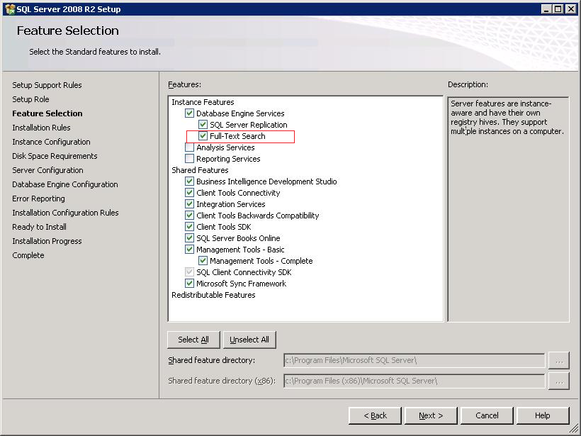

**Install Full-Text Search during SQL server installation**

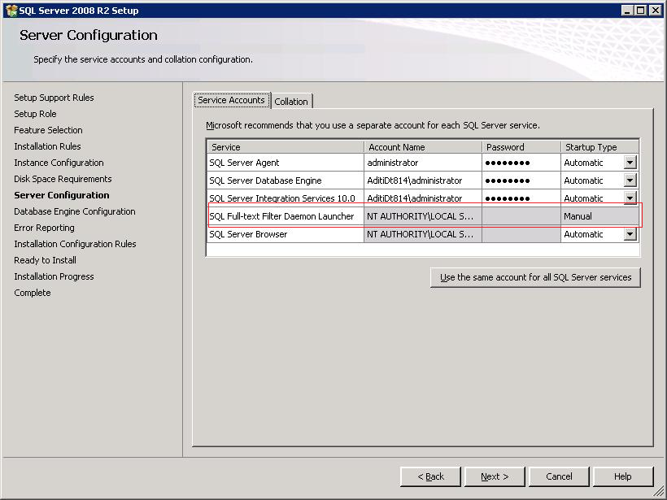

**Set Full-Text Filter Daemon Launcher Startup Type to Manual**

**Enable File Stream:**

File stream can be enabled either during the SQL Server installation or after the installation completes.

Please find the below screen shot to enable the file stream during the SQL Server installation,

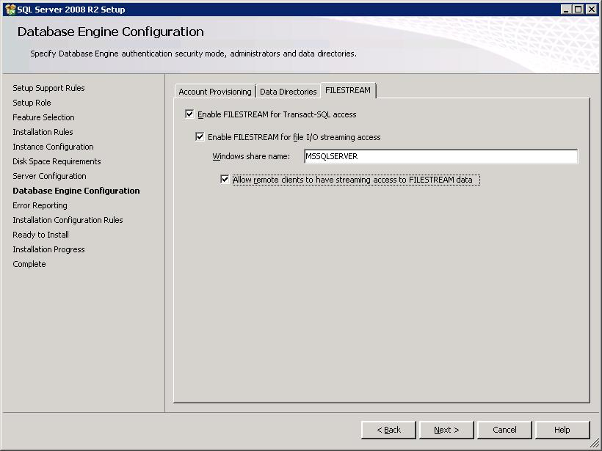

**Enable File Stream during the SQL Server installation**

Steps to enable the File stream after the SQL Server installation,

* Open “**SQL Server Configuration Manager**”
* In the left pane, expand node “**SQL Server Configuration Manager (Local)**”
* Select “**SQL Server Services**”
* In the right side pane, right click on “**SQL Server (MSSQLSERVER)**”, click on **Properties,**
* It opens the **SQL Server (MSSQLSERVER) Properties** window, go to **FILESTREAM** tab,
  + Check “Enable FILSTREAM for Transaction-SQL access” checkbox
  + Check “Enable FILESTREAM for file I/O streaming access” checkbox
  + Check “Allow remote clients to have streaming access to FILESTREAM data” checkbox

Click on **Apply**, and click **OK** to close the window.

* Open SQL Management studio and execute the following SQL query,

EXEC sp_configure filestream_access_level, 2

RECONFIGURE

**Enable Named Pipes:**

To enable the Named Pipes,

* Open “**SQL Server Configuration Manager**”
* In the left pane, expand node “**SQL Server Configuration Manager (Local)**”
* Expand “**SQL Server Network Configuration**”, Click on “**Protocols for MSSQLSERVER**”
* In the right pane, right click on “**Named Pipes**”, click on **Enable.**

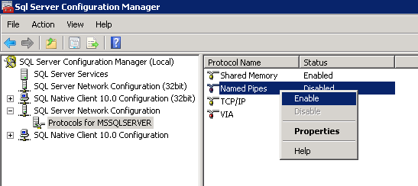

* In the left pane, expand “**SQL Native Client 10.0 Configuration**”, Click on “**Client Protocols**”.
* In the right pane, right click on “**Named Pipes**”, click on “**Enable**”

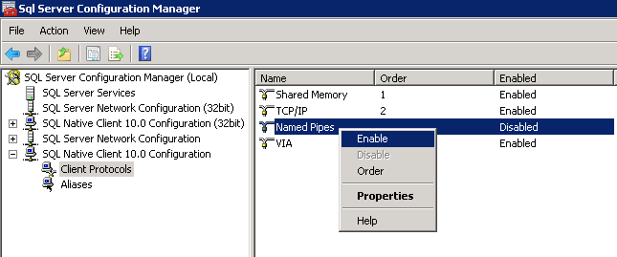

* If it is 64-bit Operating System, expand “**SQL Native Client 10.0 Configuration (32bit)**”, Click on “**Client Protocols**”.
* In the right pane, right click on “**Named Pipes**”, click on “**Enable**”

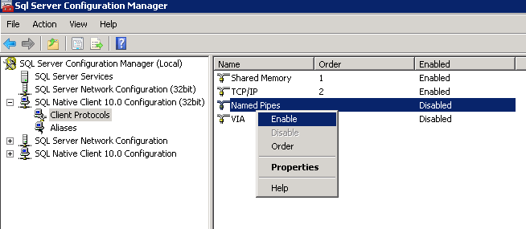

### IIS Requirements

As part of the IIS 7 installation, the following IIS components should be installed.

**Web Server**

**Common HTTP Features**

* Static Content

* Default Document

* Directory Browsing

* HTTP Errors

* HTTP Redirection

**Application Development Features**

* ASP.NET

*.NET Extensibility

* ISAPI Extensions

* ISAPI Filters

* Server Side Includes

**Health and Diagnostics**

* HTTP Logging

* Logging Tools

* Request Monitor

* Tracing

* Custom Logging

* ODBC Logging

**Security**

* Basic Authentication

* Windows Authentication

* Digest Authentication

* Client Certificate Mapping Authentication

* IIS Client Certificate Mapping Authentication

* URL Authorization

* Request Filtering

* IP and Domain Restrictions

**Performance**

* Static Content Compression

* Dynamic Content Compression

**Management Tools**

* IIS Management Console

* IIS Management Scripts and Tools

* Management Service

* **IIS 6 Management Compatibility**

* IIS 6 Metabase Compatibility

* IIS 6 WMI Compatibility

* IIS 6 Scripting Tools

* IIS 6 Management Console

**IIS Hostable Web Core**

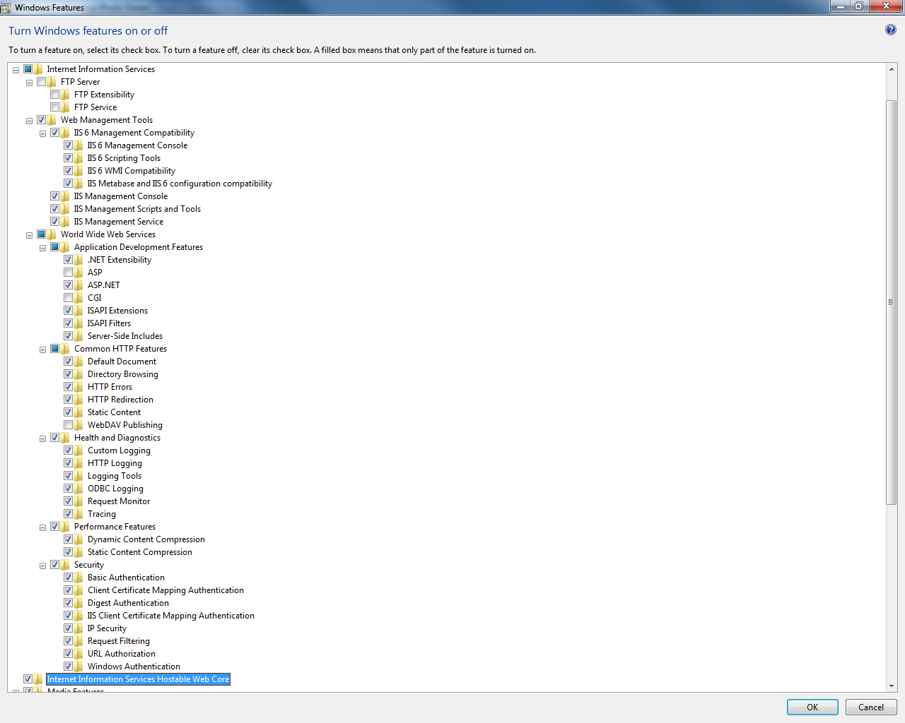

Figure – IIS 7 features in Windows 7

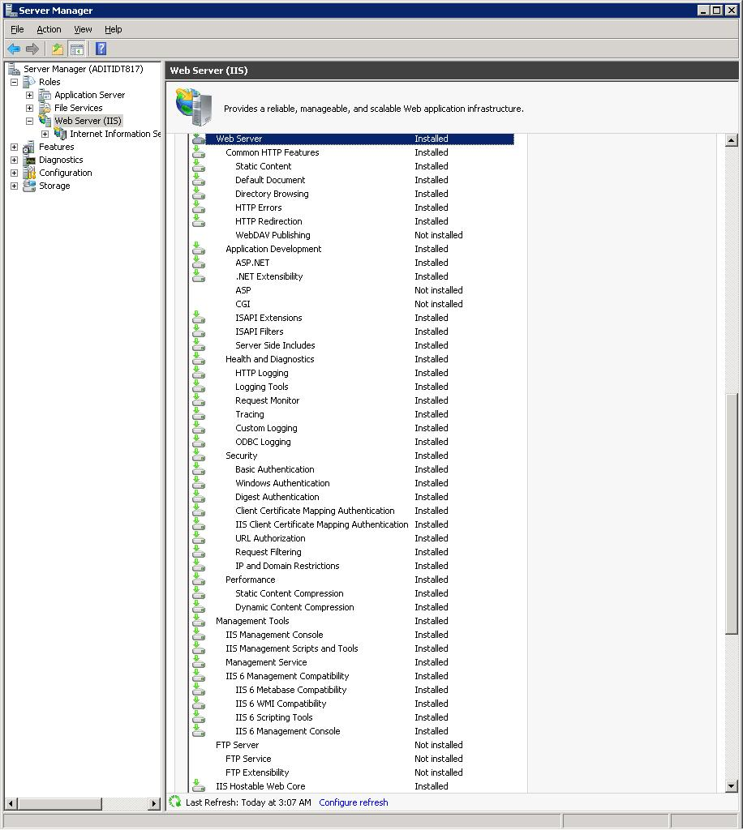

Figure – IIS 7 features in Windows Server 2008 R2

## User and Configuration Requirements

1. Administrative privileges are automatically granted to the user installing Zentity.
2. The selected Microsoft SQL Server instance must have “Windows Authentication” enabled.
3. User running the installer must have ‘database creation’ permissions on the Microsoft SQL Server instance.

# Known Issues

## Install Issues

1. The installer does not proceed further after clicking “Next”.

**Workaround**- If installer does not appear to be proceeding, look for a new window on the task bar. An error may have occurred, and the error prompt might not have the focus.

1. Fields validation being done for IIS setup dialog only check values.

For example, they do not validate whether the port entered is being already used for a different application.

# Install Instructions

## Server Installer

Copy the Installer file “**Zentity.Installer.Server.msi**” to the webserver and run it as administrator.

**Note**: To get the log file about the installation run the below command from an elevated command prompt,

msiexec /i Zentity.Installer.Server.msi /leavx log.txt

Here are the steps to complete the Zentity Server Installation

1. Click **Next** on the window “**Welcome to the Zentity 2.0 setup Wizard**” to start the Zentity installation process

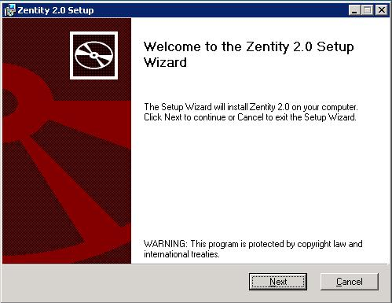

**Figure 3 – Zentity Setup Wizard Welcome screen**

1. Accept the License Agreement by checking the “**I accept the terms in the License Agreement**” check box. Click **Next** on the window “End-User License Agreement”.

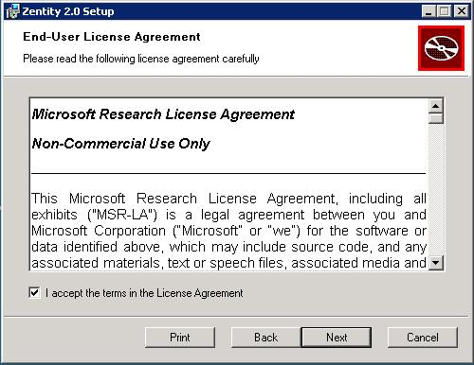

**Figure 4 – End-User License Agreement screen: agreement accepted**

1. Click **Next**  on the window “Custom Setup” shown below

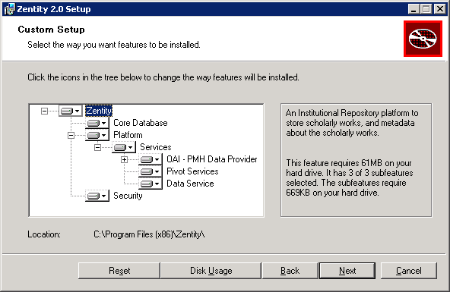

**Figure 5 – Custom Setup screen**

1. SQL Server Setup
2. Specify the SQL Server instance name for the Zentity Core Database.

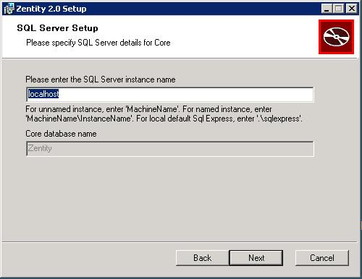

**Figure 6 – Microsoft SQL server setup Screen**

SQL Server instance name for Core

* + 1. For unnamed instance, enter ‘MachineName’ or ‘localhost’ or ‘. ‘
    2. For named instance enter ‘MachineName\InstanceName’
    3. You must specify an existing Microsoft SQL Server Instance.
    4. You must have access to the Microsoft SQL Server Instance.
    5. You must have database creation permissions on the Microsoft SQL Server Instance.
    6. You must be a member of the following role
       1. serveradmin

If ANY of the above requirements is not met, the installer will display an error message.

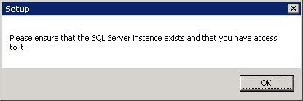

**Figure 7 – SQL Server permissions error dialog**

Once the SQL instance name specified, click the **Next** button to proceed.

* 1. The installer checks to see whether a database with the name “**Zentity**” exists on the target SQL Server instance. This is to prevent any accidental data loss that could occur if an existing database is overwritten. If a database named “Zentity” already exists on the target SQL Server instance, you will be provided with an error message.

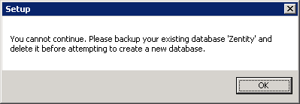

Figure 8 – Pre-existing database error for “Zentity” database dialog

* 1. Specify the content folder.

Files that are uploaded to Zentity are stored in a file system folder. Uploaded files will be stored at ‘ZentityFiles” folder.

* + 1. Ensure that there is adequate space on the drive/partition where you want to store your uploaded files.
    2. This folder and path refers to the computer that has the target Microsoft SQL Server instance in the previous step

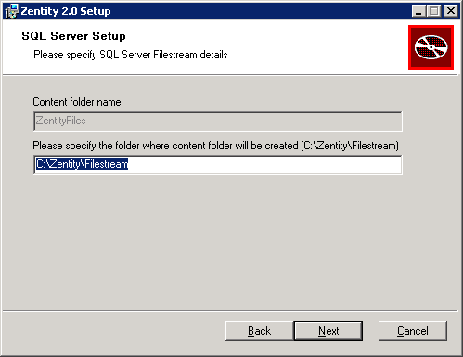

Figure 9 – Content store screen

* + 1. Please click the **Next** button to proceed.
    2. Please make sure that the location specifying for the content folder exists. Default location is “C:\Zentity\Filestream”. If the specified location is not exists then you will be provided with the following error message,

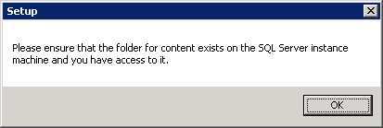

Figure 9.a- SQL Server Content folder permissions error dialog

* 1. Specify the SQL Server instance name for the OAI-PMH database.

The installer will create a database called “**ZentityPlatform**” on the specified SQL Server instance. Also, the previous notes about the permissions are applicable here too.

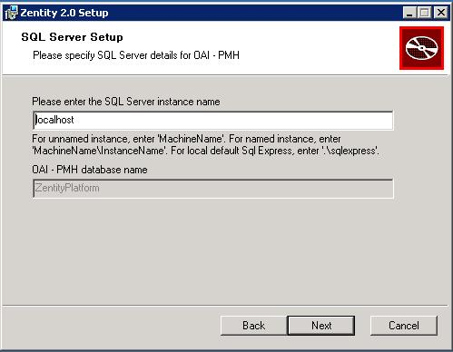

Figure 0 –Server Setup screen for Zentity Platform

Once the SQL instance name specified, click the **Next** button to proceed.

* 1. The installer checks to see whether a database with the name “**ZentityPlatform**” exists on the target SQL Server instance. This is to prevent any accidental data loss that may occur if the existing database is overwritten. If a database named “**ZentityPlatform**” already exists on the target SQL Server instance, you will be provided with an error message.

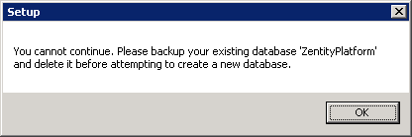

Figure 1 – Pre-existing database error for “Zentity Platform” database dialog

* 1. Specify the SQL Server instance name for the Zentity Security database

The installer will create a database called “**ZentityAuthentication**” on the specified SQL Server instance. Also, the previous notes about the file paths and permissions are applicable here too.

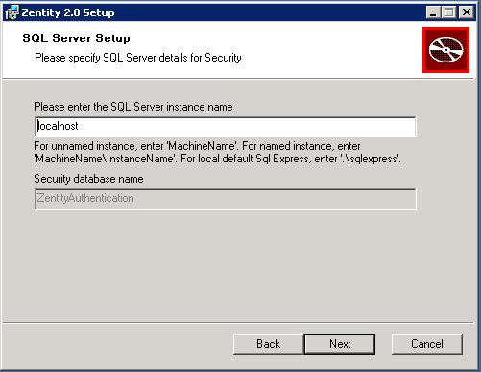

Figure 2 –SQL Server Setup screen for Zentity Authentication

Once the SQL instance name specified, click the Next button to proceed.

* 1. The installer checks to see whether a database with the name “ZentityAuthentication” exists on the target SQL Server instance. This is to prevent any accidental data loss that may occur if the existing database is overwritten. If a database named “ZentityAuthentication” already exists on the target SQL Server instance, you will be provided with an error message.

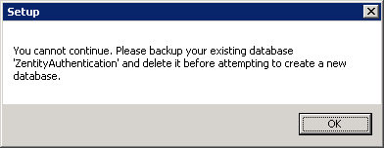

Figure 3 – Pre-existing database error for “Zentity Authentication” database dialog

1. IIS Setup

Specify the Web site name and Port numbers for the Zentity services.

1. **Web Site Name**: You may specify any desired name for the repository website.
2. **Web Site Port**: This is the port number on which the Web UI/Services will run.
   * 1. Ensure that the specified port number is not already in use.
     2. Ensure that the port number consists of only numbers
     3. Ensure that the port specified is granted inbound TCP protocol access in any firewalls present between the server and users
3. **Port for Progress Reporting Service**: Progress Reporting service is one which reports the collection creation progress to the Publishing Service.

By default the Installer provides the sample values as shown in the below screen. User can change or continue with these values.

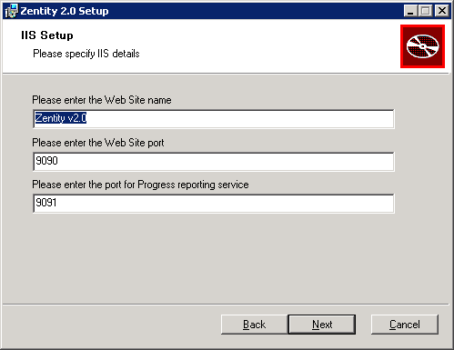

Figure 4 – IIS Setup screen

Once the details have been specified, click the **Next** button to proceed.

1. IIS Application Pool Setup
2. All the virtual directories created as part of the Zentity installation run under a specific Application Pool “**ZentityApplicationPool**”.
3. Enter valid identity under which the Zentity Application Pool will run
4. The User Name should be in the form: DomainName\UserName.

By default the installer provides the current logged-in user name as shown in the below screen. User can change or continue with this user name.

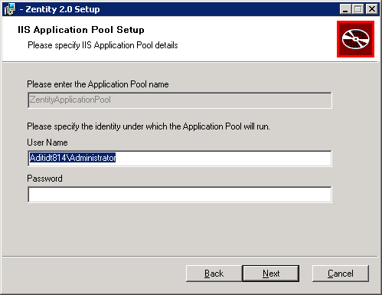

Figure 15 – IIS Application Pool Setup screen

1. Click on the **Next** button to proceed.
2. Zentity Notification Service Setup.
   1. Provide the credentials under which notification service will run.

(This dialog by default takes the user name and password specified in the step 6, User may specify the different credentials)

* 1. Specify the **Batch Size**

Batch size is the number of messages (chunk size) that the notification service will pick from the broker queue in a single request. The notification service will keep fetching messages till all messages from the broker queue are exhausted.

* 1. Specify the **Timeout** value ( in milliseconds)

Timeout is the interval period for which the notification service will sleep before querying the broker queue for new messages.

(By default the installer provides the sample values for batch size and timeout value as shown in the below screen. User can change or continue with these values.)

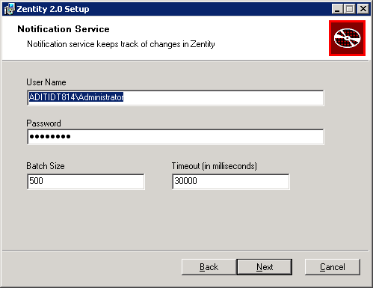

**Figure 16 – Notification Service Setup Screen**

* 1. Click on the **Next** button to proceed.

1. Zentity Pivot Services Setup
   1. Provide the credentials under which Pivot services will run.

(This dialog by default takes the user name and password specified in the step 6, User may specify the different credentials)

* 1. Specify the **Share path**, (folder where the published collections will be stored).

(By default the installer provides the sample value for Share Path as shown in the below screen. User can change or continue with this value.)

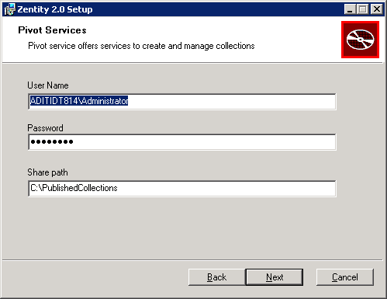

**Figure 17 – Pivot Services Setup Screen**

* 1. Click on the **Next** button to proceed.

1. Ready to install Zentity 2.0 release
   1. Click the **Install** button

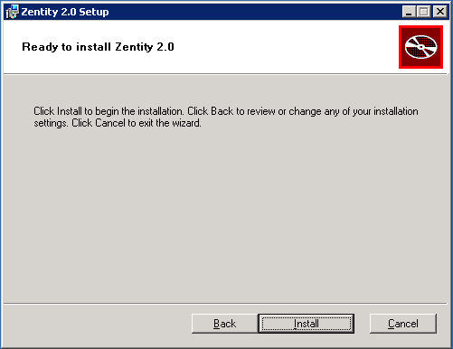

**Figure 18 – Install Screen**

* 1. Setup will continue with the installation

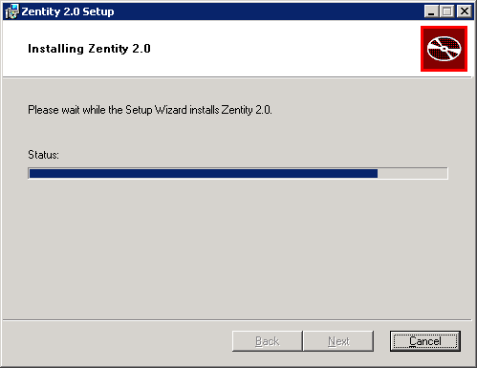

Figure 19 – Install in progress screen

* 1. When complete, click on **Finish** button to close the setup wizard.

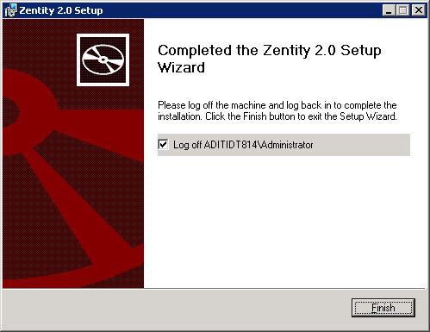

Figure 0 – Installation Completed screen

1. Once the Server installation completes, log-off the current user session.

Log-in again and start using Zentity.

## Client Installer

Double click on Client installer file “Zentity.Installer.Client.msi”.

**Note 1**: Zentity server installation should be completed before starting with the client setup.

**Note 2**: To get the log file about the installation run the below command from the Command prompt,

msiexec /i Zentity.Installer.Client.msi /leavx log.txt

Here are the steps to complete the Zentity Client Installation

1. Click **Next** on the window “**Welcome to the Zentity Client Setup Wizard**” to start the Zentity client installation process.

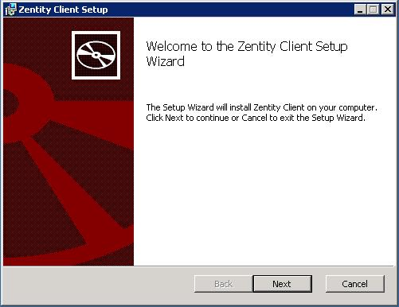

**Figure 21- Zentity Client Setup Wizard Welcome screen**

1. Accept the License Agreement by checking the “**I accept the terms in the License Agreement**” check box. Click **Next** on the window “End-User License Agreement”.

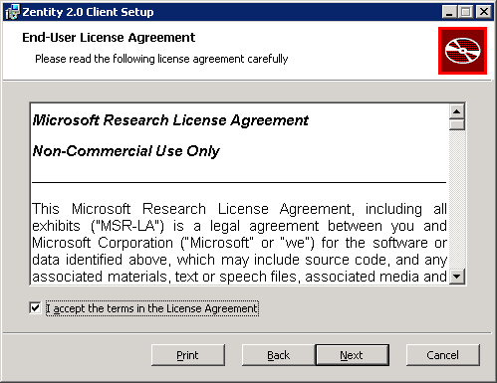

**Figure 22 – End-User License Agreement screen: agreement accepted**

1. Click **Next**  on the window “Custom Setup” shown below

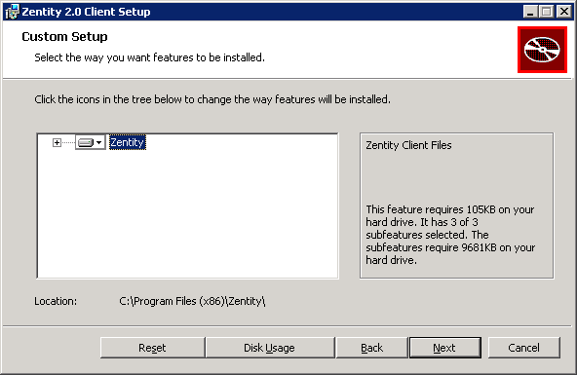

**Figure 23 – Custom Setup Screen**

1. Website details
   1. Provide the Website name which created during the Server Installation,
   2. Specify the machine name where the Website has been created
   3. Specify the Port number of the Website.

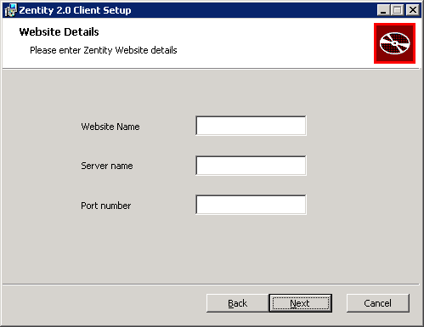

**Figure 24.A – Website details screen**

* 1. Samples values for the Website details have been provided in the below screen. Note that the port specified must be open on any firewalls between the client and the server for the TCP protocol.

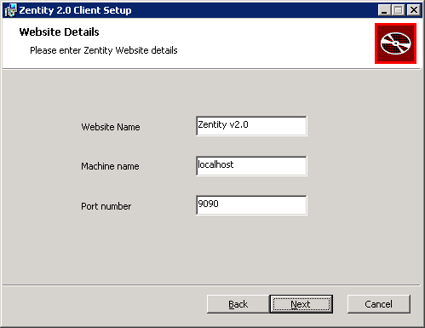

**Figure 24.B – Website details screen**

* 1. Once the details have been specified, click the **Next** button to proceed.

1. Ready to Install Zentity 2.0 Client release
   1. Click **Install** button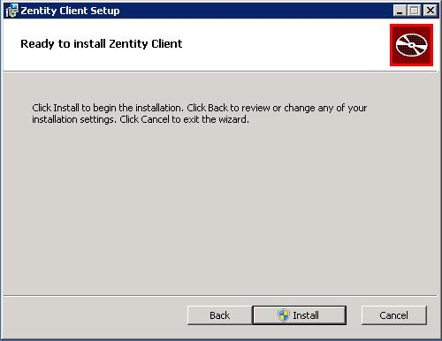

**Figure 25 – Client Install Screen**

* 1. Setup will continue with the installation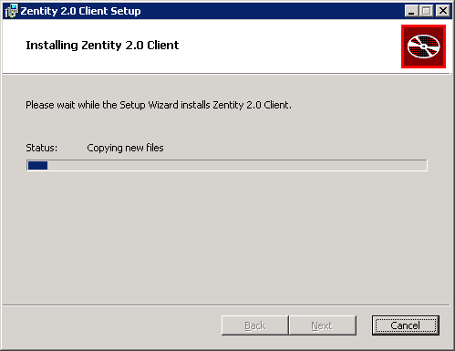

**Figure 26 – Installation in progress screen**

* 1. When complete, click on **Finish** to close the Setup wizard.

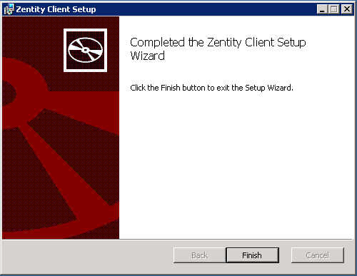

**Figure 27 – Installation completed screen**

1. Open PowerShell console as Administrator.
2. Execute the following command in the prompt.

PS C:\Windows\system32> **Set-ExecutionPolicy Unrestricted**

1. Enter “**Y**” at the prompt, and hit Enter.

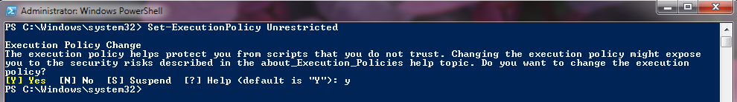

**Figure 28 – Installation completed screen**

# Uninstall Instructions

## Server Uninstallation

Double click on the Installer file “**Zentity.Installer.Server.msi**”.

Here are the steps to complete the Zentity Server Uninstallation

1. Click **Next** on the window “**Welcome to the Zentity 2.0 setup Wizard**” to start the Zentity uninstallation process

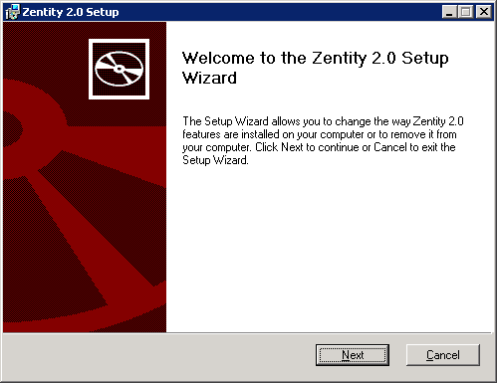

**Figure 28 – Uninstallation welcome screen**

1. Click on “**Remove**” button to uninstall the Zentity Server.

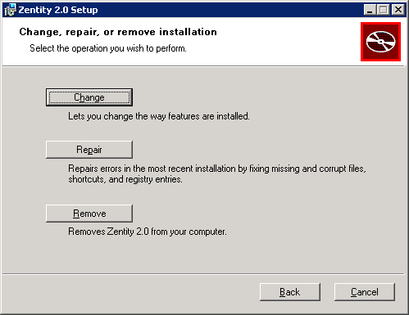

Figure 29 – Repair/Remove option screen

1. Click again on “**Remove**” button again to uninstall “Zentity”.

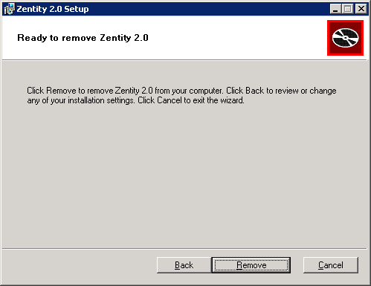

Figure 30 – Remove screen

1. Uninstall starts.

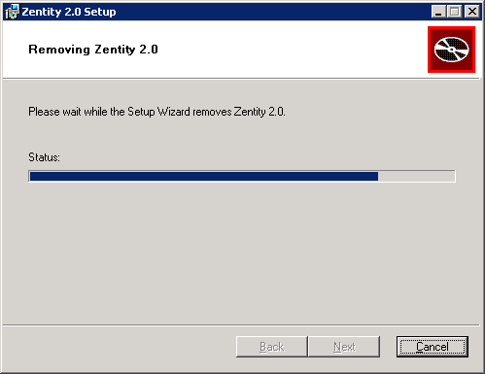

Figure 31 – Uninstallation in progress screen

1. Click on “**Finish**” button when uninstallation completes.

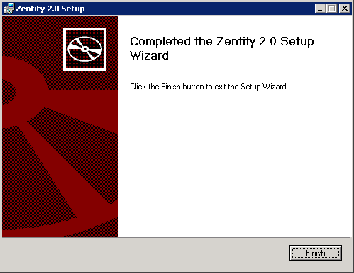

Figure 32 – Uninstallation Completed screen

## Client Uninstallation

Double click on the Installer file “**Zentity.Installer.Client.msi**”.

Here are the steps to complete the Zentity Client Uninstallation

1. Click **Next** on the window “**Welcome to the Zentity 2.0 Client setup Wizard**” to start the Zentity Client uninstallation process.

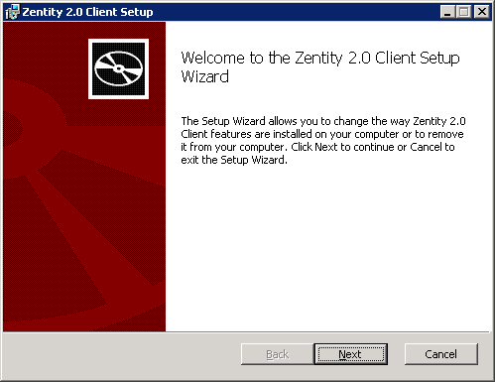

**Figure 33 – Uninstallation Welcome Screen**

1. Click on “**Remove**” button to uninstall the Zentity Client.

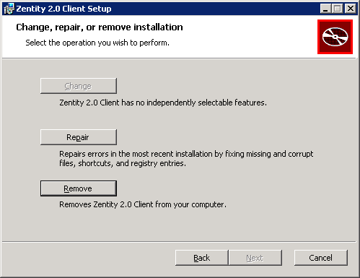

**Figure 34 - Repair/Remove option screen**

1. Click again on “**Remove**” button again to uninstall “Zentity”.

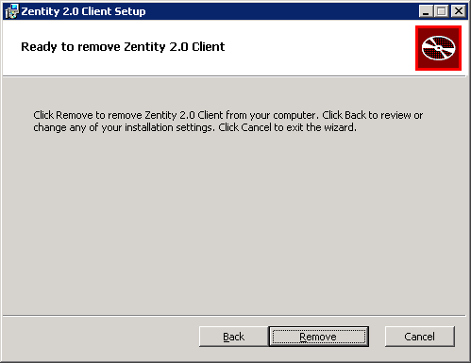

**Figure 35 - Remove screen**

1. Uninstall in progress screen.

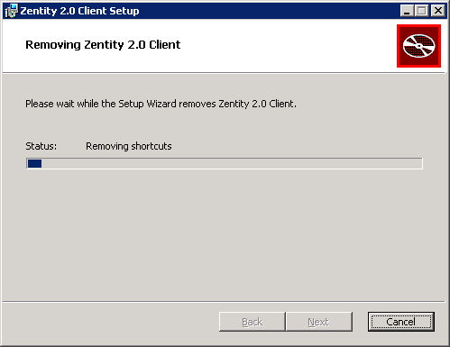

**Figure 36 – Uninstallation in progress screen**

1. Click on “**Finish**” button when uninstallation completes

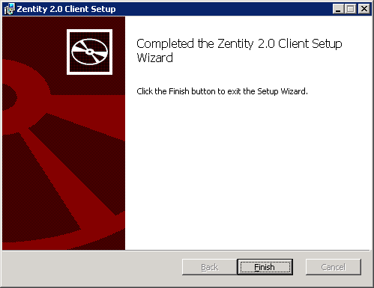

**Figure 37 – Uninstallation completed screen**

# Notes

1. The databases created by the installer are not removed during un-install.
2. Zentity provides a default administrator user with username as “administrator” and password “admin@123”.

It is advisable to change the administrator password after completion of installation.

# References (External Links)

1. “Windows SDK for Windows 7“ is available at <http://www.microsoft.com/downloads/details.aspx?FamilyID=6b6c21d2-2006-4afa-9702-529fa782d63b&displaylang=en>
2. “.Net Framework 4” is available at <http://www.microsoft.com/downloads/details.aspx?FamilyID=9cfb2d51-5ff4-4491-b0e5-b386f32c0992&displaylang=en>
3. Microsoft SQL Server 2008 Native client is available at

<http://www.microsoft.com/downloads/details.aspx?FamilyId=C6C3E9EF-BA29-4A43-8D69-A2BED18FE73C&displaylang=en>

1. “Silverlight 4” is available at

<http://www.microsoft.com/getsilverlight/Get-Started/Install/Default.aspx>

1. Windows PowerShell 2.0 is available at

<http://www.microsoft.com/downloads/en/details.aspx?FamilyID=50633A1F-A665-425D-923C-1A269F8AC084&displaylang=en>

# Troubleshooting Section

1. Error in Zentity Dashboard with the error message as “Zentity Services are not accessible right now. Please try again later or contact the administrator”.

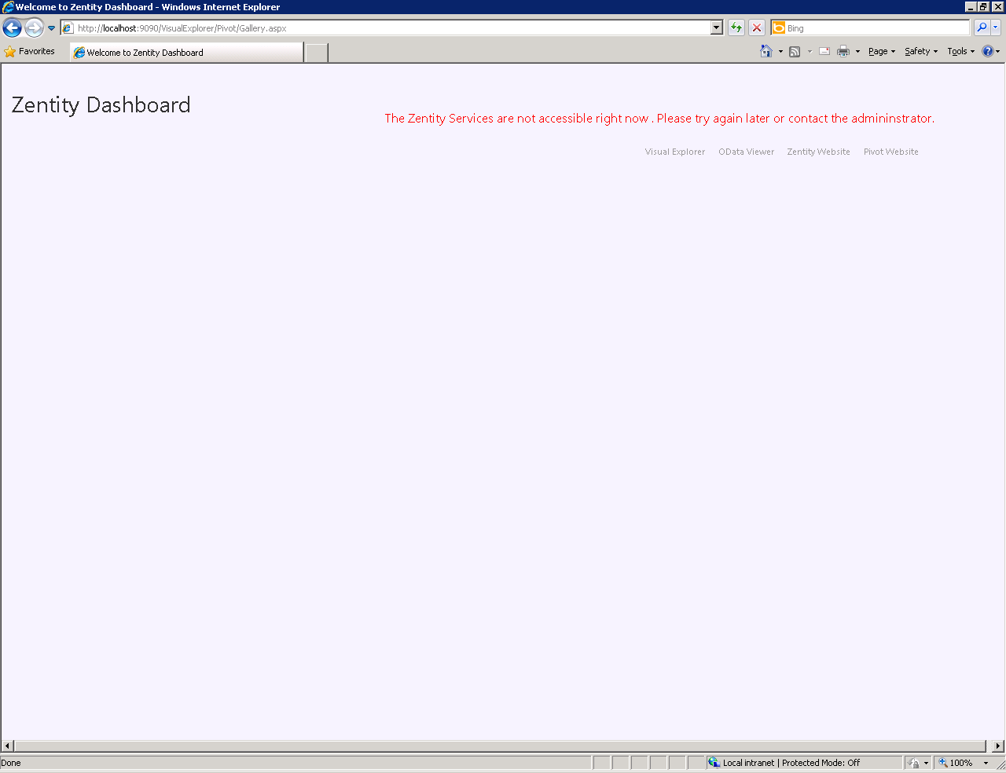

**Figure 1-A: Error in Zentity Dashboard**

**Cause**: Primary reason for this is “**Publishing Service**“ might be stopped running.

**Solution**: Open Command Prompt with administrator privileges, execute the below command to start the service: **net start PublishingService**.

Please find the below screenshot with the clear details to run the above command.

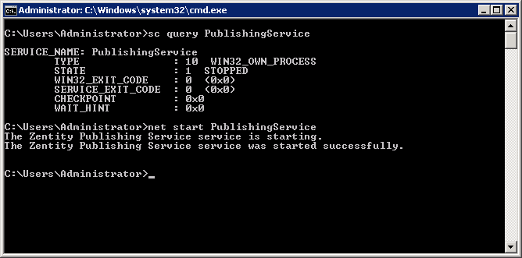

**Figure1-B: Starting Publishing Service**

1. Error in creating collections :

PowerShell commandlet “**Create-ZentityPivotCollectionFromResourceType**” fails with the error message as below,

*Create-ZentityPivotCollectionFromResourceType : Exception calling "CreateCollection" with "2" argument(s): "There was no endpoint listening at http://localhost:9090/Pivot/PublishingService that could accept the message. This is often caused by an incorrect address or SOAP action. See InnerException, if present, for more details."*

*At line:1 char:46+ Create-ZentityPivotCollectionFromResourceType <<<< Zentity.ScholarlyWorks Journal*

*+ CategoryInfo : NotSpecified: (:) [Write-Error], WriteErrorException*

*+ FullyQualifiedErrorId : Microsoft.PowerShell.Commands.WriteErrorException,Create-ZentityPivotCollectionFromResourceType*”

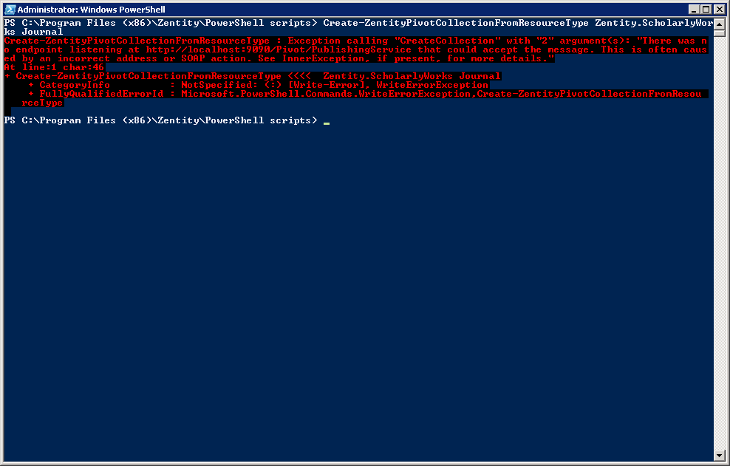

**Figure2-A: Error in Collection Creation**

**Cause**: Primary reason for this is “**Publishing Service**” might be stopped running.

**Solution**: Open Command Prompt with administrator privileges, execute the below command to start the service. **net start PublishingService**.

Please find the below screenshot with the clear details to run the above command.



**Figure2-B: Starting Publishing Service**

1. Unable to load the PowerShell scripts in the console.

Error message as below,

*File C:\Program Files (x86)\Zentity\PowerShell scripts\PublishingConfigService.ps1 cannot be loaded because the execution of scripts is disabled on this system. Please see "get-help about_signing" for more details.*

*At line:1 char:2+ . <<<< .\PublishingConfigService.ps1*

*+ CategoryInfo : NotSpecified: (:) [], ParentContainsErrorRecordException*

*+ FullyQualifiedErrorId : RuntimeException*

**Cause**: This is due to the execution of the scripts is disabled on the system

**Solution**: Set the execution policy to RemoteSigned. Run the below command in the PowerShell console.

**Set-ExecutionPolicy RemoteSigned**

Please find the below screenshot with the clear details to run the above command.

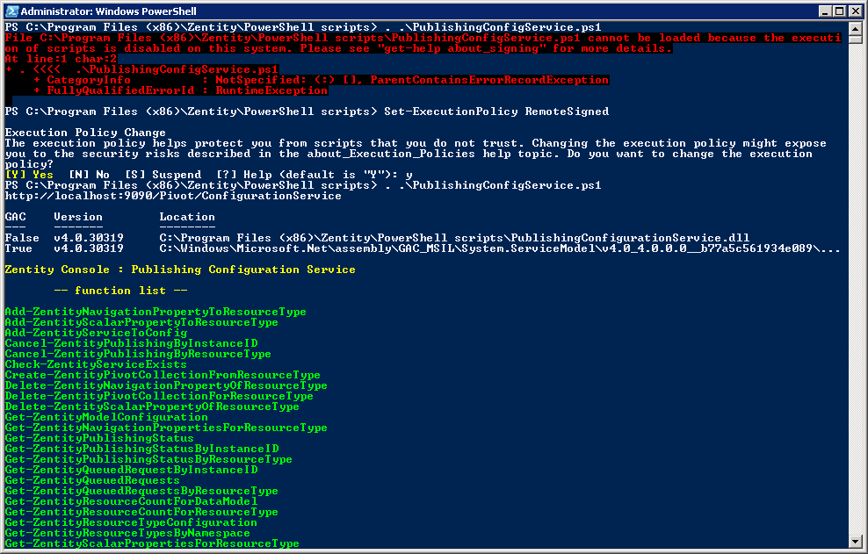

**Figure 3: Set Execution Policy in the PowerShell console**

1. Error in Zentity Server installation,

The error message is “Cannot connect to Internet Information Server. (-2147221164 )”.

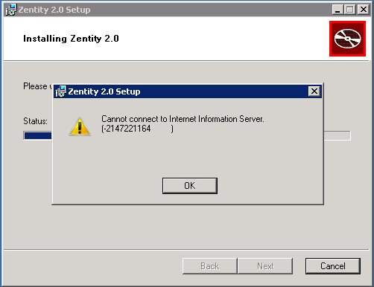

**Figure 4: Error in Zentity Server Installation due to IIS**

**Cause**: This error is due to missing IIS 6 compatibility pack.

**Solution**: Install IIS Role Service “IIS 6 Management Compatibility”.

1. Error in Zentity Server installation

The error message is “Error -2147467259: failed to create SQL database: Zentity, error detail: unknown error.”

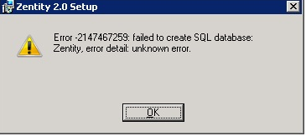

**Figure 5A- Error in Zentity Server Installation due to**

**Named Pipes not enabled**

**Cause**: This is due to “Named Pipes” is not enabled on the SQL server.

**Solution**: Follow the below process to enable the “Named Pipes”,

* Open “**SQL Server Configuration Manager**”
* In the left pane, expand node “**SQL Server Configuration Manager (Local)**”
* Expand “**SQL Server Network Configuration**”, Click on “**Protocols for MSSQLSERVER**”
* In the right pane, right click on “**Named Pipes**”, click on **Enable.**



**Figure 5B-Enable Named Pipes**

* In the left pane, expand “**SQL Native Client 10.0 Configuration**”, Click on “**Client Protocols**”.
* In the right pane, right click on “**Named Pipes**”, click on “**Enable**”



**Figure 5C-Enable Named Pipes**

* If it is 64-bit Operating System, expand “**SQL Native Client 10.0 Configuration (32bit)**”, Click on “**Client Protocols**”.
* In the right pane, right click on “**Named Pipes**”, click on “**Enable**”



**Figure 5D- Enable Named Pipes**

* Restart the SQL services.

1. Zentity Database log grown to unmanageable size.

**Solution**: Run the following SQL Script to reduce the log file size to 200MB.

USE Zentity;

GO

-- Truncate the log by changing the database recovery model to SIMPLE.

ALTER DATABASE Zentity

SET RECOVERY SIMPLE;

GO

-- Shrink the truncated log file to 200 MB.

DBCC SHRINKFILE (Zentity_Log, 200);

GO

-- Reset the database recovery model.

ALTER DATABASE Zentity

SET RECOVERY FULL;

GO

1. Resource search fails in the Visual Explorer.

**Cause**: SQL Server Agent might be in stopped state

**Solution**: Start SQL Server Agent.

* + Go to, Start -> Administrative Tools -> Services.
  + Look for service named as “**SQL Server Agent (MSSQLSERVER)**”.
  + Right click on the service, click on **Start**.

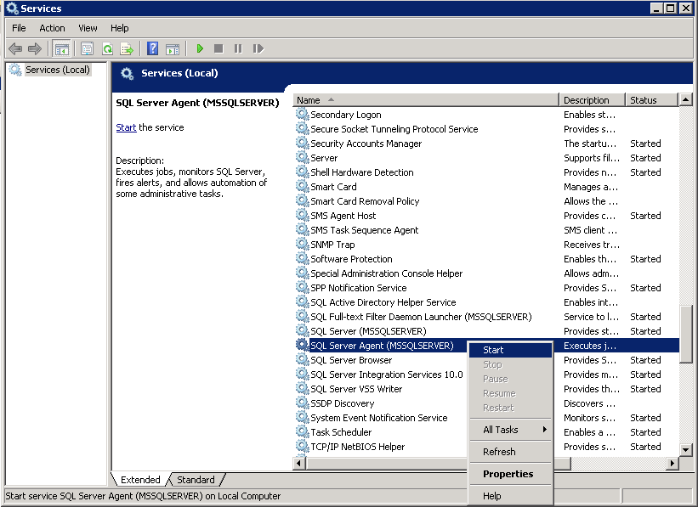

**Figure 5: Start SQL Server Agent**

1. Publishing status lost after Service restart / System reboot.

**Cause**: SQL server was stopped or inaccessible at the time Zentity Services were starting.

**Solution**:

The recovery of services is done on service startup and the information is fetched from Zentity Database. If this database is not available at service startup, then the state of the services after reboot cannot be recovered from.

This will impact the collection status on Zentity Dashboard and also the status returned by the PowerShell Cmdlets.

1. Exception “**SecurityNegotiationException**” while executing PowerShell Cmdlets.

Ex: Execute the below Cmdlet

\>: Open-ZentityHostConfigurationFile

Exception thrown as below,

*Exception calling "OpenHostConfigurationFile" with "0" argument(s): "****SOAP security negotiation with 'http://localhost:9090/Services/AdminConfigurationService' for target 'http://localhost:9090/Services/AdminConfigurationService' failed****. See inner exception for more details."*

*At D:\Zentity\PowerShell Scripts\AdminConfigService.ps1:164 char:64*

*+     return $global:adminConfigService.OpenHostConfigurationFile <<<< ()*

*+ CategoryInfo          : NotSpecified: (:) [], ParentContainsErrorRecordException*

*+ FullyQualifiedErrorId : DotNetMethodException*

**Cause**: Zentity Services are secured with WCF’s message based security that uses Windows authentication. When Zentity services are installed on the server, the credentials to run the services are supplied to the installer. If the username for the service account is changed in future, all clients that are working on the initial username will fail.

**Solution**: Execute the following steps in order.

* + Run the following script in the same PowerShell window. Please substitute the “DOMAIN\username” with the new server account username. You may need to obtain the username from your Zentity administrator.  
    => **Add-ZentityServiceToConfig UserPrincipalName “DOMAIN\username”**
  + Exit the PowerShell window.
  + Reload the PowerShell script.

1. Dashboard does not show progress of Pivot Collection creation.

**Cause**: Dashboard is designed to load data from the Zentity Services and Filesystem only on initial page visit (GET Request). The data is bound to the grid and cached in session. On sorting actions on the grid (POST Requests), the data is not refreshed and served from the session cache. This saves the page from thrashing the Zentity Services and File system.

**Solution**: To get fresh data on to the page, you need to click on the "Zentity Dashboard" link located at the top left of the page.

1. Click on “**Bing Search**” and ”**View in Zentity**” links in Visual Explorer details window does not respond.

Cause: Pop-up blocker configured in the browser or installed toolbars block opening new windows

Solution: Configure pop-up blocker or installed toolbars appropriately for the Visual Explorer website.

1. Click on “**Visual Explorer**” in Pivot Viewer does not respond.

**Cause**: Pop-up blocker configured in the browser or installed toolbars block opening new windows

**Solution**: Configure pop-up blocker or installed toolbars appropriately for the Visual Explorer website.